**Greenhouse management problem business analysis**

**Introduction:**

I have been selected for helping a Greenhouse management problem. There are a lot of potential problems when it comes to greenhouses and production of fruits and vegetables. They vary from choosing what crops to grow, how to take care of them, should the greenhouse be seasonal or all year around, transporting the crops, finding a market to sell, being able to keep with competitors’ prices, setting up technology and sensors and managing to control this huge project. It is hard to find a solution right away for everything but after researching and looking up to surveys it can be done.

**Problems:**

After reading through three interviews and going through a survey there has been some problems that people mentioned more than once. The main problem I found was about the outdated digital technology in the greenhouses. The employees waste a lot of time and energy checking the greenhouses and their sensors manually. There is a technology that the greenhouse is using but it is so outdated that some calculations need to be made manually. Another problem is that more than eighty percent of the employees think that the production made should be seasonal and not all year around. A little less than the half of the company is filled with workers older than 46 years of age. This is a problem as well because most of the elderly people cannot keep up with today’s technology and tempo of work.

**Solutions:**

1. The first thing to do would be to buy and implement a new digital technology that would monitor essential information like humidity and temperature. The system should also be able to signal immediately if a sensor breaks or is not responding. The employees will be able to monitor the processes from home and not waste energy on physically checking the crops and manually calculating information.
2. Have a meeting of the board directors about changing the Greenhouse from all year around to a seasonal one. Making this decision will satisfy a lot of the workers and will also help the company to earn more because if the Greenhouse works only for one season it can be well suited for this season efficiently.
3. Using chemicals will be a good idea and maybe your only option to keep with competitors with warm weather. Using chemicals can help with the growth of the crops, their size and yield. The economic situation of the company will improve and they will start earning more.
4. Swap workers who are older than 46 years with young people who are more energetic and waiting for challenges. Young people who are not tired of life tend to show more desire to work and get paid. They have not figured their lifes yet and are craving for experience and financial independency.

**Relevant Diagrams:**

This diagram shows that 38% of the workers are 46 years or older

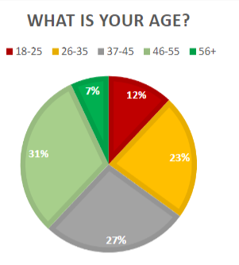

**Stakeholder analysis:**

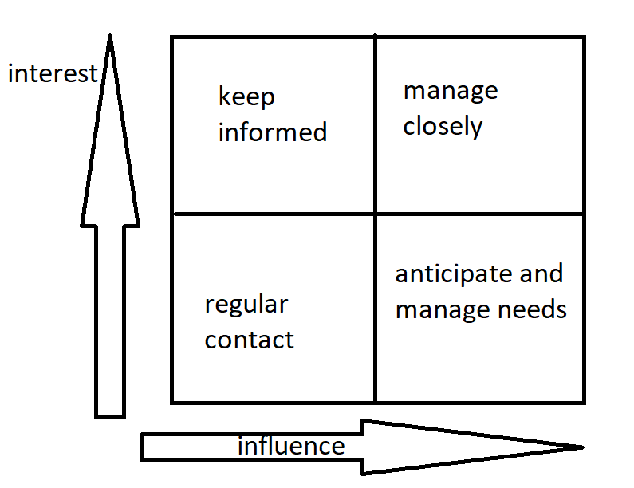

**References:**

The survey

The interviews